Instruction for System B

(This instruction is assumed to run on Windows system to run bat file.)  
**1. To start the system:**1-1.       Open command prompt window  
1-2.       Open SystemB folder  
1-3.       Type **Start.bat** on command prompt window and hit Enter.  
1-4.       When a message that “Starting ECS system” is appeared, then hit Enter key.  
1-5.       Then, original system consoles will be appeared on a screen.  
1-6.       To operate security system, hit Enter key again on the command prompt window.  
1-7.       Then, console windows related to security system will be appeared on the screen.    
  
**2. To operate the system:**  
2-1. Among consoles of security system, you need to find “MUSEUM ENVIRONMENT CONTROL SYSTEM SECURITY CONSOLE”.  It looks like this.

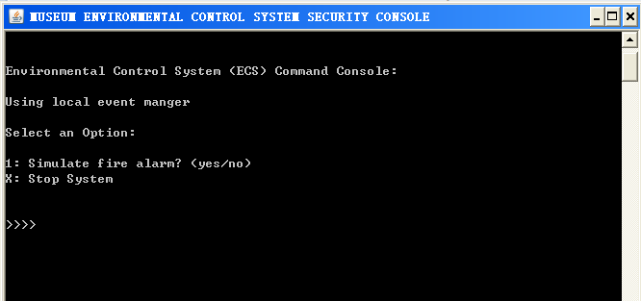

2-2. Put number (1 or 2) to test the system or “X” to stop and exit the system.

2-3. If you type “1”, you could simulate a fire alarm

2-3-1. if you do not open the sprinkler, the sprinkler will be opened in 15 seconds, then you will see option “3” to turn off the sprinkler.

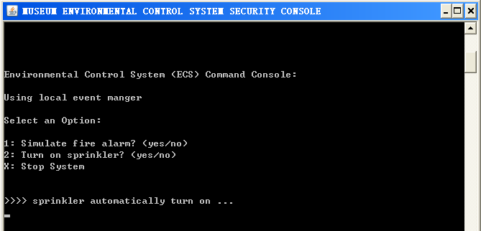

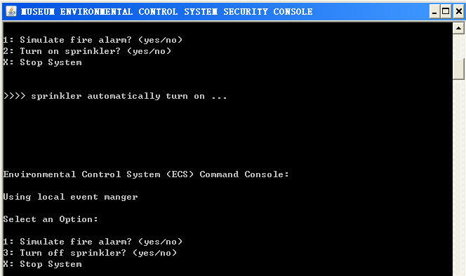

2-4. If you type “3” and hit enter key, then you could turn off the sprinkler. (You can check whether the event is reported or not on the *monitor console*)